**Template Creation – Story & Use Cases**

**Purpose**

This feature enables Pantry Managers to create structured templates for specific types of food pantry announcements. Templates include categorized types (e.g., Emergency Pickup, Weekly Update) and message placeholders like {food_type} or {campus_location}. This supports consistent messaging, minimizes writing effort for staff, and helps target announcements to the right audience. Templates are reusable, managed by staff, and protected from unauthorized access.

**User Story**

As a Food Pantry Manager, I want to create announcement templates grouped by type (e.g., 'Special Offers, 'Pantry Closure'),  
So that staff can easily select and fill in appropriate messages, And I want to control access to ensure only authorized staff can create or modify templates.

**Acceptance Criteria (Sprint 1)**

- Each template must include:

* A unique name
* A subject line
* A message body with placeholders
* A required template type (e.g., Weekly Update, Emergency)
* Templates must be saved only if the name + type combination is unique
* Only managers and pantry staff may access or create/edit templates
* Tags should be explained (e.g., via a help sidebar or tooltip)

|  |  |  |
| --- | --- | --- |
| **Template Type** | **Purpose** | **Example Tags** |
| **New Food Arrival** | To quickly inform subscribers about newly received food items, specifying the type and availability period. Managers will select this template and fill in the names of the new items and when they will be available. | {{food_item}}, {{availability_start}}, {{availability_end}} |
| **Special Offer** | To announce limited-time special offers or discounts on specific food items. Managers will use this to highlight the discounted item and the duration of the offer. | {{item_name}}, {{discount}}, {{start_date}}, {{end_date}} |
| **Pantry Closure** | To notify subscribers about temporary closures of the Food Pantry, specifying the date(s) and reason. This ensures students are aware and don't arrive when the pantry is closed. | {{closure_date}}, {{reason}}, {{reopening_date}} |
| **Event Announcement** | To inform subscribers about upcoming events related to the Food Pantry (e.g., food drives, information sessions). Managers will use this to detail the event name, date, time, and location. | {{event_name}}, {{date}}, {{time}}, {{location}} |
| **Low Stock Reminder** | To alert subscribers about items that are running low, encouraging them to visit soon if they need these items. This helps manage expectations and potentially reduce waste. Managers will specify the items with low stock. | {{low_stock_item}} |

**Standard Use Cases for Template Types includes dynamic content:**

**Template Tag Reference Table:** Below is a reference table explaining all dynamic tags used across the different notification templates. Each tag is enclosed in double curly braces and is replaced at runtime with real values entered by pantry staff.

|  |  |
| --- | --- |
| **Tag** | **Description** |
| **{{food_item}}** | Name of the newly arrived food item (e.g., Apples, Bread) |
| **{{availability_start}}** | The date when the food becomes available at the pantry |
| **{{availability_end}}** | The last date the food will be available |
| **{{item_name}}** | The item that is on special offer or discount or simply a availability |
| **{{discount}}** | The discount percentage or value being offered |
| **{{start_date}}** | Start date of the offer or promotional period |
| **{{end_date}}** | End date of the offer or promotional period |
| **{{closure_date}}** | The date on which the pantry will be closed |
| **{{reason}}** | The reason for the pantry's closure (e.g., maintenance, holiday) |
| **{{reopening_date}}** | The date when the pantry will reopen |
| **{{event_name}}** | The name or title of the scheduled event |
| **{{date}}** | The calendar date of the event |
| **{{time}}** | The starting time of the event |
| **{{location}}** | The location or room where the event will occur |
| **{{low_stock_item}}** | Name of the item that is running low in inventory |
| **{{campus_location}}** | The campus where the pantry or event is located |

**Template Management Responsibilities – RACI Matrix Summary:** This section outlines the roles and responsibilities associated with the creation, usage, and oversight of notification templates within the Food Insecurity Notification System. A RACI matrix is used to clarify who is Responsible, Accountable, Consulted, and Informed for each key action in the template workflow.

* **Responsible (R):** The person(s) who actually complete the task
* **Accountable (A):** The person ultimately answerable for the task’s success
* **Consulted (C):** The person(s) who provide input and feedback
* **Informed (I):** The person(s) kept up to date on progress

|  |  |  |  |  |  |
| --- | --- | --- | --- | --- | --- |
| **Role** | **CREATE** | **EDIT** | **DELETE** | **VIEW** | **USE TEMPLATE** |
| **Pantry Manager** | R / A | R / A | R / A | R | C |
| **Pantry Staff** | - | - | - | R | R / A |
| **Others** | - | - | - | - | - |

**Templates**:

|  |
| --- |
| **Template – New Food Arrival** |
| **Template Name**: New Food Arrival  **Subject** Fresh {{food_item}} Just Arrived at {{campus_location}}!  **Message Body**  Dear Students,  Good news! We’ve just received a fresh batch of {{food_item}} at the {{campus_location}} pantry.  These items will be available starting from {{availability_start}} through {{availability_end}}, or while supplies last.  Make sure to stop by and pick some up during our open hours. Thank you for being a part of the PCC pantry community!  Regards, PCC Pantry Management Team |

|  |
| --- |
| **Template – Special Offer** |
| **Template Name**: Special Offer  **Category/Type**: Promotions  **Subject** Limited Time Offer on {{item_name}} – Only at {{campus_location}}!  **Message Body**  Dear Students,  Exciting news! We’re offering a limited-time discount of {{discount}} on {{item_name}} at the {{campus_location}} pantry.  This offer is valid from {{start_date}} to {{end_date}} – so be sure to visit before it ends!  Quantities are limited, and items are available on a first-come, first-served basis.  We hope you take advantage of this special offer to support your needs.  Regards, PCC Pantry Management Team |

|  |
| --- |
| **Template – Pantry Closure** |
| **Template Name**: Pantry Closure  **Subject** Pantry Closed on {{closure_date}} – Reopening on {{reopening_date}}  **Message Body** Dear Students,  Please be advised that the pantry at {{campus_location}} will be closed on {{closure_date}} due to {{reason}}.  We apologize for any inconvenience this may cause. The pantry will reopen on {{reopening_date}}.  Thank you for your understanding.  Regards, PCC Pantry Management Team |

|  |
| --- |
| **Template – Event Announcement** |
| **Template Name**: Event Announcement  **Subject** Join Us for {{event_name}} at {{campus_location}}  **Message Body** Dear Students  We’re excited to invite you to {{event_name}} hosted by the PCC Pantry at {{campus_location}}!  Event Details: - Date: {{date}} - Time: {{time}} - Location: {{location}}  Come connect with your community, learn more about pantry services, and participate in fun activities!  We look forward to seeing you there!  Regards, PCC Pantry Management Team |

|  |
| --- |
| **Template – Low Stock Reminder** |
| Template Name: Low Stock Reminder  **Subject** Hurry! {{low_stock_item}} Running Low at {{campus_location}}  **Message Body**  Dear Students,  Heads up! Our stock of {{low_stock_item}} at the {{campus_location}} pantry is running low.  If you rely on this item, please try to visit the pantry soon to pick some up before it’s gone.  Thank you for your continued engagement with our services.  Regards, PCC Pantry Management Team |

**Template Manager Graphical User Interface for Pantry Manager:**

**Overview**: The Template Manager is part of the Food Pantry Notification System. It allows managers to create, edit, and delete standardized message templates. Staff members can select and use these templates when sending pantry-related communications.

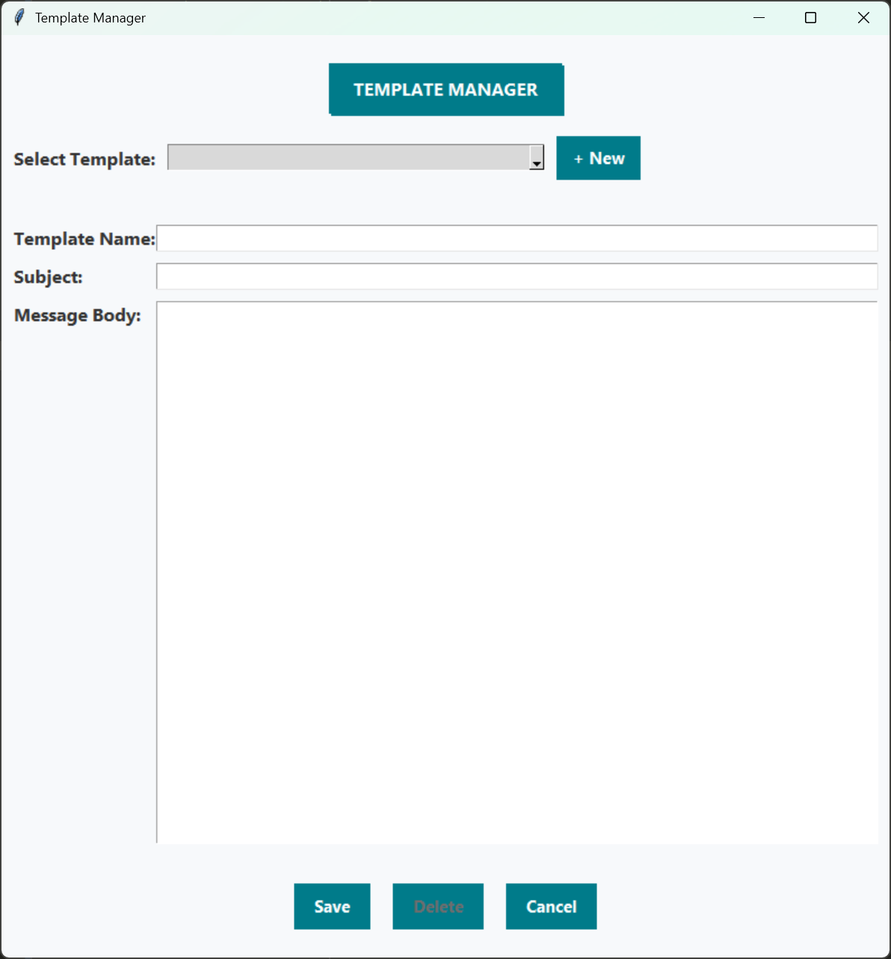

**How Managers Use the Template Manager:**

1. **Create a New Template**:
   1. Click the '+ New' button.
   2. Fill in the Template Name (must be unique), Subject, and Message Body.
   3. Click the 'Save' button to store the new template.
2. **Edit an Existing Template**:
   1. Select the template from the dropdown menu.
   2. Make changes to the Subject and Message Body fields.
   3. Click 'Save' to update the template.
3. **Delete a Template**:
   1. Select the template from the dropdown.
   2. Click the 'Delete' button and confirm the prompt.